**Shell and Bash**

**ubuntu@ip-172-31-10-134:~$ man bash**

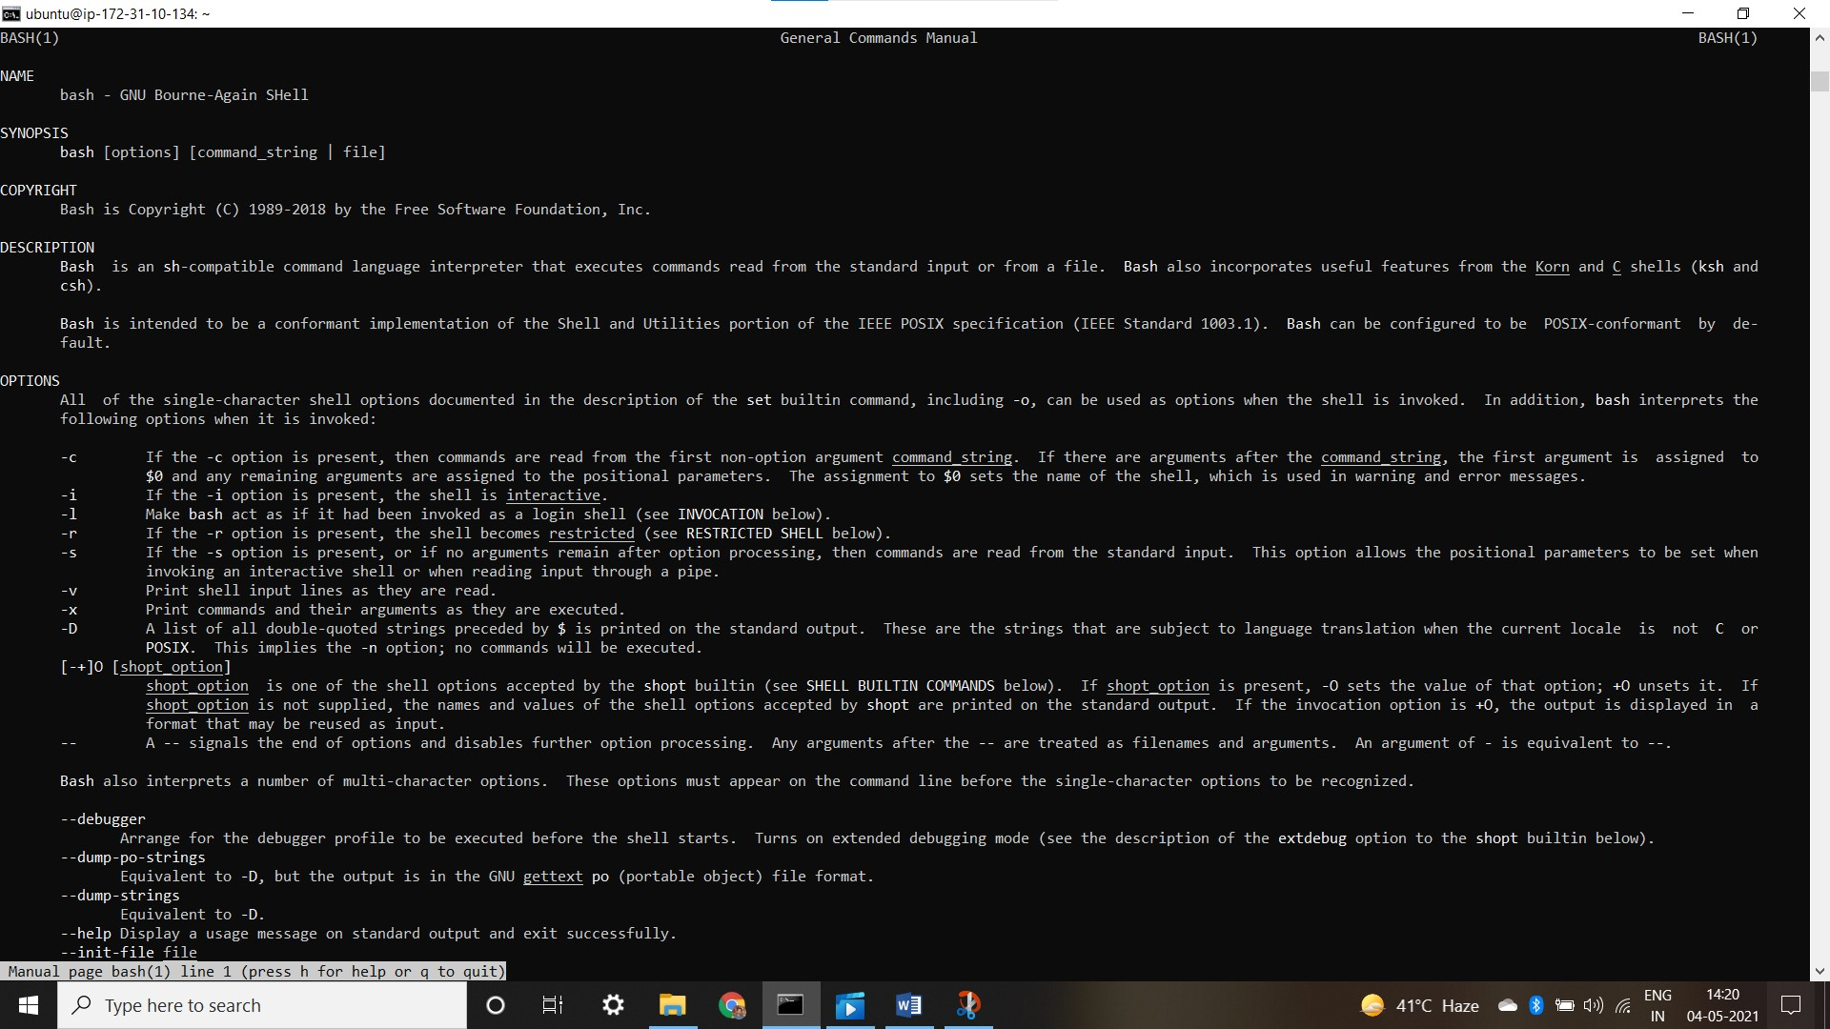

**ubuntu@ip-172-31-10-134:~$ clear**

* Use this command for clear the screen

**ubuntu@ip-172-31-10-134:~$ ls**

**test.txt**

**ubuntu@ip-172-31-10-134:~$ which ls**

**/usr/bin/ls**

**ubuntu@ip-172-31-10-134:~$ man which**

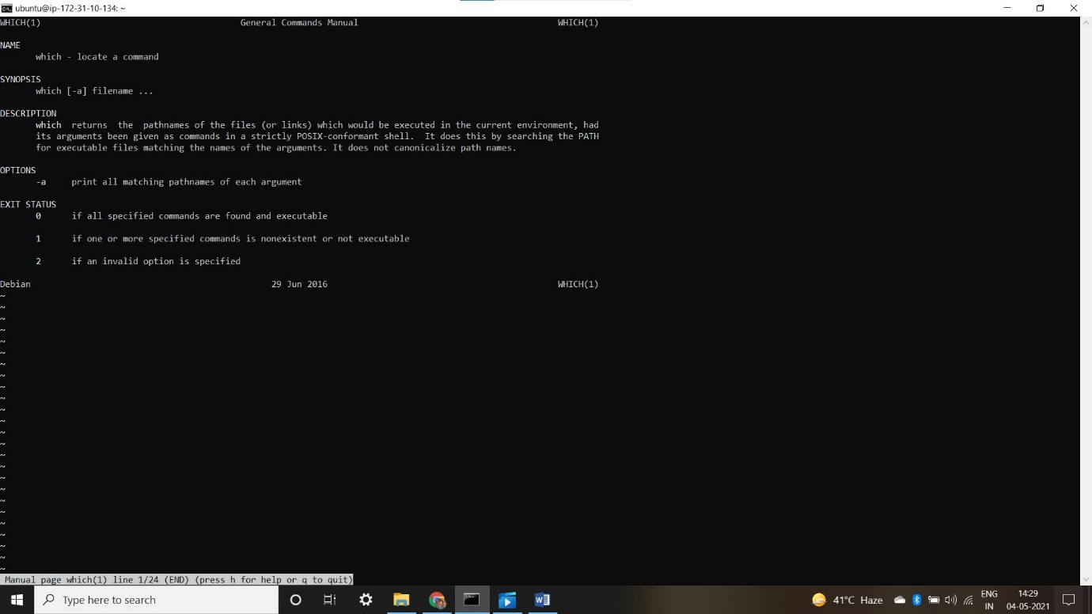

**ubuntu@ip-172-31-10-134:~$ ls –al**

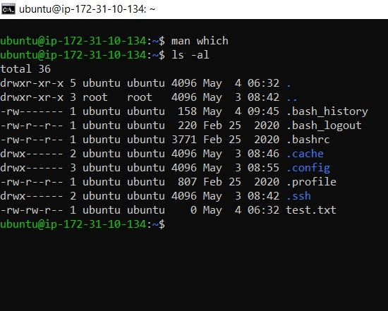

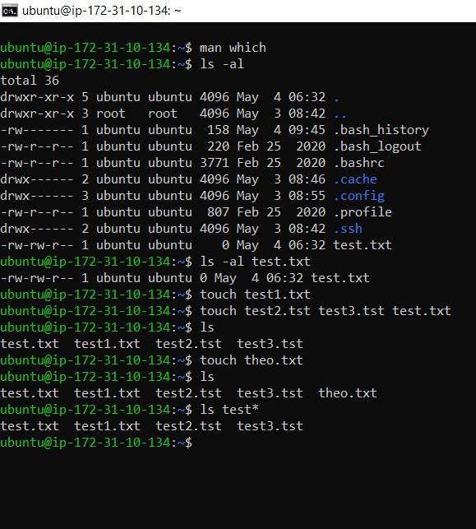

**ubuntu@ip-172-31-10-134:~$ ls -al test.txt**

**ubuntu@ip-172-31-10-134:~$** touch test1.txt

**ubuntu@ip-172-31-10-134:~$** touch test2.tst test3.tst test.txt

**ubuntu@ip-172-31-10-134:~$ ls**

test.txt test1.txt test2.tst test3.tst

**ubuntu@ip-172-31-10-134:~$ touch theo.txt**

**ubuntu@ip-172-31-10-134:~$ ls**

test.txt test1.txt test2.tst test3.tst theo.txt

**ubuntu@ip-172-31-10-134:~$ ls test* (* means find )**

test.txt test1.txt test2.tst test3.tst

* we create test.txt file
* **test.txt test1.txt test2.tst test3.tst** Here we create **test1.txt file , test2.tst , test3.tst , test.txt** file
* We use **touch** command to create a file.
* We use ls command to see our file.
* We use ls test* command to delete last file what we created.

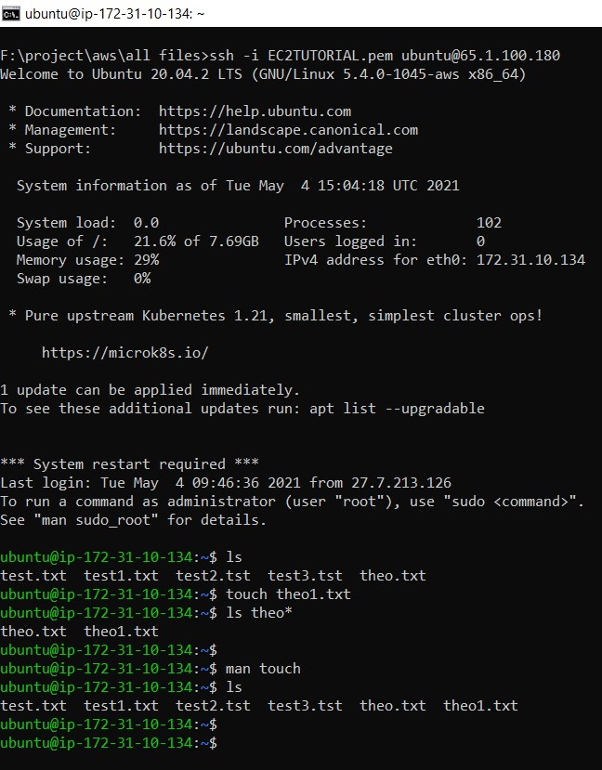

* **ubuntu@ip-172-31-10-134:~$** touch theo1.txt

we created theo1.txt file

* ubuntu@ip-172-31-10-134:~$ ls theo*
* theo.txt theo1.txt
* ubuntu@ip-172-31-10-134:~$
* ubuntu@ip-172-31-10-134:~$ man touch
* ubuntu@ip-172-31-10-134:~$ ls
* test.txt test1.txt test2.tst test3.tst theo.txt theo1.txt
* ubuntu@ip-172-31-10-134:~$